January 2025

Two Systems,

One Machine

**Professor:** Alex Alexander

|  |  |
| --- | --- |
| **Student Name** | **Student ID** |
| Yusuf Mohmed Mamun | 4393527 |
| Rudra Gojariya | 4393716 |
| Cheshwan Bhutta | 4392562 |

Table of Contents: A Journey Awaiting Discovery

Introduction 3

Requirements 4

Installing Multiple Operating Systems in VirtualBox 5

1) Installing Oracle VirtualBox 5

2) Installing the First OS (Windows 10) 6

3) Installing The Second OS (Windows 8): 10

4) Configuring the Default OS 13

5) Creating the User Data Volume 15

Conclusion 18

# Introduction

Running more than one operating system on a single machine has increased in value in today's fast-paced technological environment. Whether it be testing, development, or personal preference, dual booting allows users to harness the strengths of different operating systems without the need for separate hardware. However, creating a multi-operating system environment requires careful planning and execution for system stability and data integrity.

This technical guidance is supposed to walk a person through the process of installing multiple operating systems on one computer and creating a volume of user data. By separating the user data from the drives containing the operating systems, users can achieve greater flexibility, easier backups, and improved system recovery options.

The step-by-step instructions, visuals, and troubleshooting tips will ensure that the exercise is smooth and successful. Whether one is starting to dual boot or wants to refine his/her skills, this guide will equip him/her with the knowledge to manage multi-OS installations and optimize data storage confidently.

# Requirements

Before proceeding, ensure you have the following:

* A computer with sufficient resources (RAM, CPU, and disk space).
* Oracle VirtualBox installed on your host machine.
* ISO files for Windows 8 and Windows 10.
* Sufficient disk space.
* Adequate RAM.

# Installing Multiple Operating Systems in VirtualBox

## A screenshot of a computer Description automatically generatedInstalling Oracle VirtualBox.

* + 1. Begin by going to the OracleVirtualBox site at https://www.virtualbox.org/ and downloading the current version of the software. Make sure to choose the right installer for your host operating system (i.e., Windows, macOS, or Linux). Check that your system has the minimum requirements, like disk space and RAM, to prevent installation problems. Save the installer file to your computer in a directory, like the Downloads directory, where it will be handy to use in the following step.
    2. Execute the installer file downloaded to start the installation. Follow on-screen instructions, ranging from accepting the licensing agreement to selecting an install directory and deciding on optional features such as USB support or network drivers. Unless you have particular customization requirements—like changing advanced settings or installation targets—keep the default options set to simplify setup. Installation might require administrative privileges, so provide them when prompted. Once done, VirtualBox will be installed and ready to use for virtual machine creation and management.

## Installing the First OS (Windows 10).

* + 1. Start by launching Oracle VirtualBox and pressing the "New" button to launch the VM creation wizard. Give it a descriptive name (like "Dual-Boot-System-VM") and choose "Microsoft Windows" as the type and "Windows 10" as the version. When you are asked to choose an ISO image, choose "Others" from the drop-down menu and navigate to where you saved the Windows 10 ISO file. Choose "Skip Unattended Installation" so that you can maintain manual control over the installation process.

* + 1. Proceed to the "Hardware" section in VM settings to allocate system resources. Set the "Base Memory" (RAM) as per the capability of your host machine, e.g., 4GB (4096MB) for medium performance. Proceed to the "Hard Disk" section and choose "Create a virtual hard disk now" to set up storage. Go with the default VDI format and dynamically allocated storage for optimizing space.
    2. Set the virtual hard disk size to 100GB to provide ample space for both operating systems and user data. Complete the configuration by selecting "Finish," which finalizes the setup installation of the VM. This provides a virtual environment that simulates a physical machine, awaiting the installation of Windows 10.

* + 1. Install Windows 10 Boot the VM from the Windows 10 ISO by launching the VM. Follow the on-screen instructions until you reach the type of installation screen. Choose "Custom: Install Windows only (advanced)" so that you have the opportunity to partition the virtual hard disk manually. Allocate a primary partition of 36,000MB (36GB) to Windows 10 and a secondary one of 42,000MB (42GB) to Windows 8, and leave the rest of the space unallocated for future use.

* + 1. Finish the installation of Windows 10 by responding to prompts to configure regional settings, create a user account, and specify a password. When finished, the VM will restart into Windows 10. Leave the remaining free disk space available for the user data volume that will later be formatted to hold files that can be shared between the two operating systems. This completes the OS setup, with the VM now ready to install Windows 8.

## Installing The Second OS (Windows 8).

* + 1. Prior to continuing with installing Windows 8, make sure that you completely power down the Windows 10 virtual machine (VM). Save any open documents in applications running in the VM and use the host's VirtualBox console to choose "Shut Down" from the machine menu or gracefully shut down via the Windows 10 shutdown method. This will avoid data corruption and ready the VM for configuration changes.

* + 1. Open VirtualBox go to the "Settings" window of the VM and then click on the "Storage" tab. Find the virtual optical drive that has the Windows 10 ISO mounted under the "Storage Devices" menu. Eject this ISO file by clicking on the disk icon and then clicking "Remove Disk." Mount the Windows 8 ISO by clicking on the empty optical drive, clicking "Choose a Disk File," and finding the location of the Windows 8 ISO. Save these settings by clicking "OK" to complete the setup.

* + 1. Start the VM by pressing the "Start" button in VirtualBox. While the VM is booting, you will see a prompt, "Press any key to boot from CD or DVD." Press any key on your keyboard quickly so that the VM will boot from the Windows 8 ISO rather than the already existing virtual hard disk. This will initiate the installation of Windows 8.
    2. Continue with the on-screen setup until you get to the installation type prompt. Choose "Custom: Install Windows only (advanced)" to gain access to manual partitioning options. Under the list of available disk spaces, pick the 42,000MB (42GB) partition that was set aside for Windows 8 when installing Windows 10. Continue with partition formatting (if necessary) and let the installer copy files and install the OS.

* + 1. When the installation is finished, the VM will boot into Windows 8. Follow the prompts to configure personalized settings such as region, language, and time zone. Create a user account and password to secure the OS. After setup, the VM will boot into the Windows 8 desktop, finalizing the dual-boot setup with Windows 10. The reserved unallocated space will be formatted later as a shared data volume for use by both operating systems.

## Configuring the Default OS.

* + 1. Begin by starting the virtual machine and booting the Windows 10 operating system. After the OS is completely loaded, open the System Configuration tool. To accomplish this, press the Win + R keys at the same time to open the Run dialog box, type msconfig, and then press Enter. This opens the System Configuration window that offers the tools to set up startup options as well as system settings.
    2. In the System Configuration window, select the Boot tab to view a list of installed operating systems. Select Windows 10 in the list and click the "Set as default" button to set it as the priority for the first OS to boot. Set the Timeout value to 10 seconds, which decreases the time the boot menu is displayed before the default OS automatically loads. This provides a quicker bootup while still giving time to choose Windows 8 manually when required.

* + 1. Once you have set the options, click Apply to apply your changes, then click OK to dismiss the window. You will be prompted to reboot the system right away—affirm this to complete the setup. Upon reboot, the dual-boot menu will be displayed for 10 seconds before falling back to Windows 10. This finishes the setup, making the boot process straightforward while still allowing flexibility to use Windows 8 when needed.

## Creating the User Data Volume.

* + 1. Start by booting up the virtual machine and starting Windows 10. Once the OS is loaded, launch Disk Management, the tool responsible for managing storage devices. You can search for "disk management" in the Start Menu and click on "Create and format hard disk partitions," or you can hit Win + R, type diskmgmt.msc, and hit Enter. The tool provides you with a graphical view of your virtual hard disk, both allocated and free space.

* + 1. Under Disk Management, find the unallocated space reserved previously under Windows 10 and 8 installations. Right-click on this unallocated space and choose "New Simple Volume…," then run the setup wizard. Complete the prompts to determine the volume size (unless partitioning multiple times, utilize all of the unallocated space). Assign a drive letter, i.e., D:, for quick identification of the volume. To be compatible with both Windows 8 and Windows 10, select the file system NTFS and assign a descriptive label like "User Data" to distinguish the volume purpose.

* + 1. 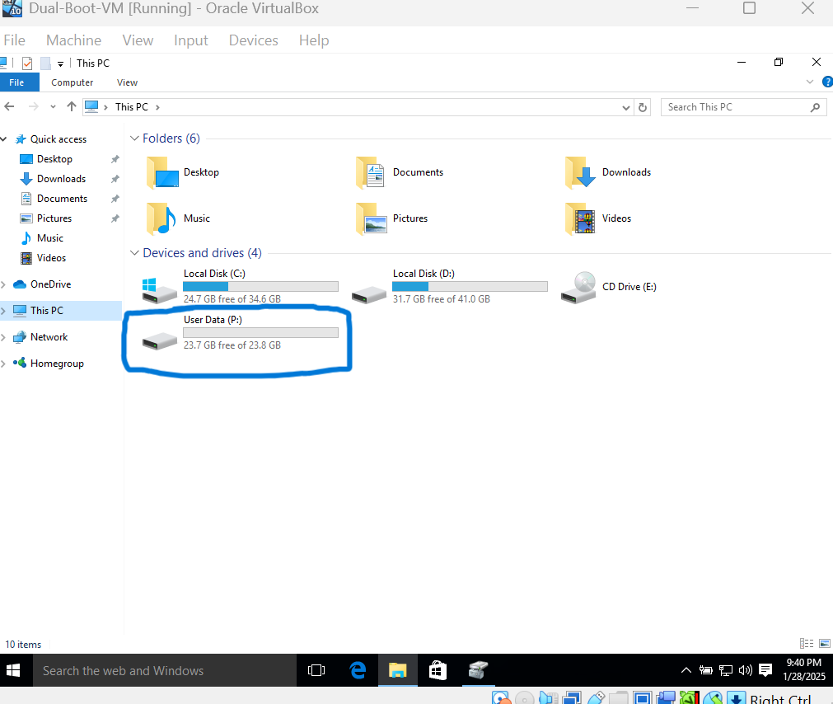Finish the wizard by selecting "Finish" to format and enable the new volume. The drive should now be visible in Windows Explorer as an available storage point. Use this shared folder to place files you want to have available under both operating systems in the dual-boot setup, without having to duplicate files. Restart the virtual machine if you are asked to do so and test the volume by saving a test file to the new drive.

# Conclusion

This guide presents an easy, step-by-step procedure for dual-booting Windows 8 and Windows 10 on Oracle VirtualBox to allow users to have both operating systems on the same machine but keep user data isolated for security. By having different partitions for both OSes and a common NTFS volume, technical personnel can sufficiently test software, debug problems, or train between OS versions without incurring hardware expenses or data exposure. The dual-boot configuration eases cross-platform operations, and the organized documentation provides consistency for support teams. The project emphasizes the value of accurate technical writing in leading complex IT procedures.